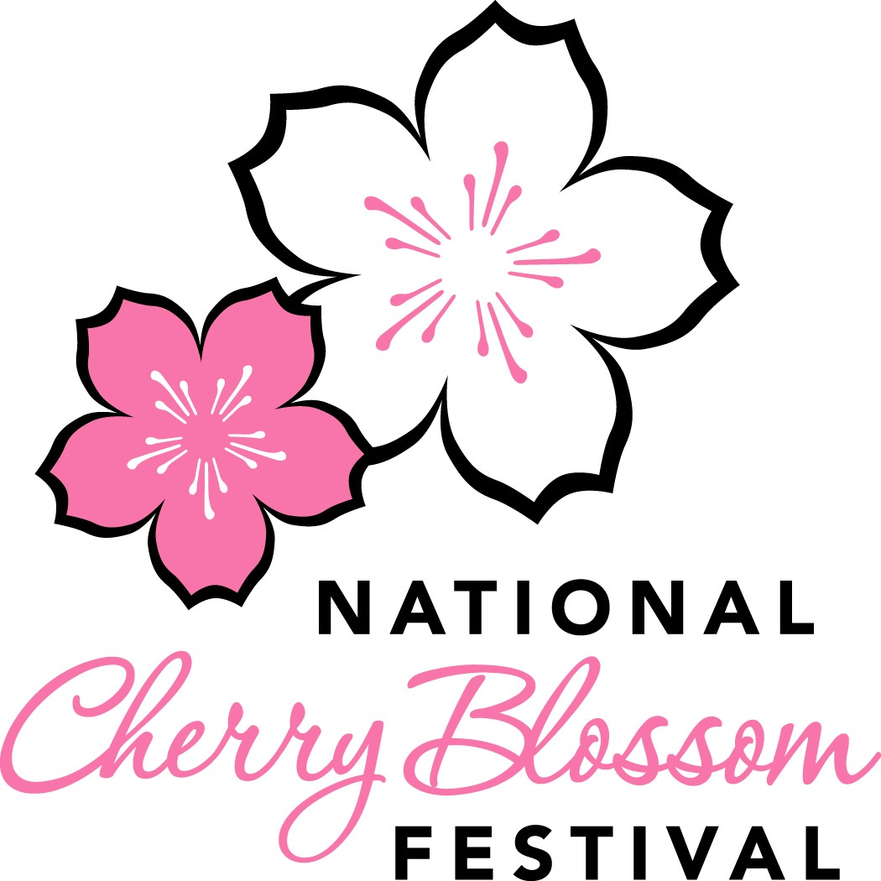
2018 National Cherry Blossom Festival Parade®
Minor Participant Release Form

(Please Print in Black or Blue Ink Only)

I will:

1. Allow my child (listed above) to participate in the National Cherry Blossom Festival Parade scheduled to take place on Saturday, April 14, 2018 along Constitution Avenue between 7th and 17th Streets, NW, Washington, DC (“Event”).

2. Certify that my child is physically fit and able to participate in the Event.

3. Acknowledge that my child will not be compensated for his or her participation in the Event.

3. Assume all risks of personal injury, property loss or death that may occur related to my child’s participating in the Event. Along with my heirs, executors and administrators, I waive all current and future legal claims against the National Cherry Blossom Festival, Inc., the District of Columbia, the National Park Service, EventsDC, JM Best Entertainment Inc., Under the Sun Productions Inc., WJLA-TV and each of their respective sponsors, officers, directors, employees, agents, representatives, successors, and assigns (collectively, “Presenters”).

4. Acknowledge that my child is not covered by any Presenter insurance.

5. Authorize any necessary medical treatment to my child at the Event, at my cost.

6. Indemnify and defend, together with my heirs, executors and administrators, and those of my child, the Presenters from all liabilities, claims, actions, damages, costs or expenses, including claims based on the Indemnitee’s negligence, arising out of or connected with third party claims related to my participation in the Event.

7. Ensure that my child will not take any action that would negatively impact the Event or the Event’s reputation, will follow Event rules, and will leave the Event if NCBF requires.

8. Allow NCBF and NCBF's agents, without reservation, limitation or additional compensation, the right to record, in any media, and to use, broadcast or produce derivative works from, in any media and for all time, my child’s name, face, likeness, voice and appearance.

Intending to be legally bound, I sign this Release on the date below.

Date: _______________________ Signature: _________________________________________
_________________________________________
Printed Name of Parent or Guardian

If your child is participating with an organization or group, please list the name of that organization or group:

George Washington Chapter of the Model A Ford Club ______________________________________________________________

